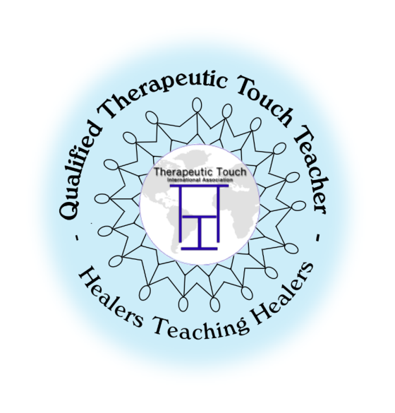
THE TRANSPERSONAL NATURE OF
  - THERAPEUTIC TOUCH
In this Therapeutic Touch® (TT) course, we build on the knowledge, skills, and insights acquired through the TT Foundations course and regular TT practice. This course supports and enhances the learner’s evolving and deepening understanding of Therapeutic Touch. We will explore in-depth approaches for assisting individuals with a variety of health challenges. It includes more hands on practice, reflective inquiry, and self inquiry exercises. And as always, peace and healing is the nature of the class for all who come! This course satisfies the second class required for the credential of Qualified Therapeutic Touch Practitioner (QTTP) however it is open to those who wish to deepen their practice but are not pursuing a QTTP. All sessions are required.

DATES: November 5th, 6th & 7th 2021 with pre-class reading (14 total hours)
TIME: Friday 6:00 – 9 PM CDT, Saturday & Sunday 10a to 5pm CDT
LOCATION: Zoom
Class Fee $175.00
Prerequisite required: Foundations of Therapeutic Touch
Continuing Nursing Education (CNE) Units – The Transpersonal Nature of Therapeutic Touch® This continuing nursing education activity was approved by the American Holistic Nurses Association (AHNA), an accredited approver of continuing nursing education by the American Nurses Credentialing Center’s Commission on Accreditation.#1472
Mary Anne Hanley, PhD RN QTTT, a student of Dolores Krieger and Dora Kunz, has been practicing and teaching Therapeutic Touch (TT) since 1984 and has participated in and conducted research related to TT. Most recently, she has published about the Human Energy Field and the Theory of Healing. Currently, President of TTIA, she has served in the roles of Education Trustee and Research Trustee. She is the Chair of the Global Academy of Holistic Nursing Scholarship.
Marilyn Johnston-Svoboda, EdD RN QTTT has been practicing TT since the early 80’s, a student of Dora Kunz and Dr Dolores Krieger, creators of TT. A retired nursing professor, she teaches TT to numerous groups of nurses, nursing students and community individuals. She served as the TTIA Credentialing Trustee, and is currently serving on the Education and Community committees for TTIA. She integrates her holistic value system and beliefs which are reflective of her Native American heritage, into her TT practice and teaching.

THE TRANSPERSONAL NATURE OF
  - THERAPEUTIC TOUCH®
  - DATES: November 5th, 6th & 7th 2021 with pre-class reading (14 total hours)
LOCATION: Zoom
TIME: Friday 6:00 – 9 PM CDT, Saturday & Sunday 10a to 5pm CDT
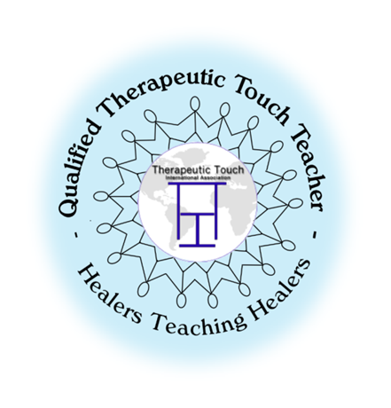
Class Fee $175.00
For the Transpersonal Nature of TT Electronic Workbook add $10.00
contact Marilyn for scholarship info
To register please fill out and return by October 20, 2021 to
Marilyn at 9imagin@gmail.com
Information on how to pay will be sent after your application has been reviewed.
=========================================================================
Name: _________________________________________________________________
Address: _______________________________________________________________
City: _____________________________________ ST: ________ Zip: ______________
Phone #: _____________________________ Cell: ____________________________
E-mail: _________________________________________________________________
Date Foundations of TT Taken: __________ Instructor(s): ___________________________
Have you practiced TT online? Yes ____ No ____ How many times: ________
Attended a TT Practice group? ____ In Person ____ Online ______
Other TT workshops/webinars attended since Foundations -please list: _________
_______________________________________________________________________
Other complementary modalities studied: __________________________________
March, 2021 Transpersonal Nature of TT

