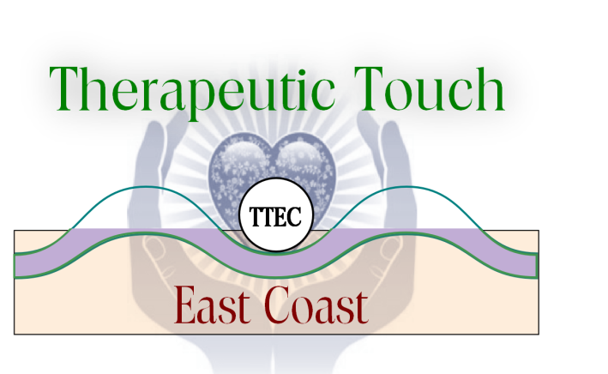
A Satellite Chapter of Therapeutic Touch International Association
Presents
Transformational Caring:
Identity ~ Igo ~ Intuition
=
A Therapeutic Touch Peer Conversation

November 20, 2021
9:30am-12:30pm
On ZOOM

Presenters: Cheri Brady APRN QTTT with Holly Major APRN QTTT
and Christina Lim APRN QTTP

Come to an interesting and thought-provoking interactive peer dialogue. Get ready to delve deeper into yourself as a Therapeutic Touch Practitioner. Examine the role that Identity, Igo (ego), and Intuition play in your Therapeutic Touch process. How do these three “I”s evolve in our transformation process as a caring individual? How do they intertwine with one another as we grow and change? This interesting Zoom program will include didactic, group chat, Q&A, and an environment to try new concepts and ways of thinking about yourself as a Therapeutic Touch Practitioner.
(Limited to 20 participants. First come, first served!)

Retreat FEE: Free TTEC Members $30 non-members
(fee toward first year membership)

Contact Linda Gurick: lgurick@gmail.com to register. Non-members may mail check

TTEC
PO Box 851
Middlebury, VT 05753

Please make checks payable to TTEC

