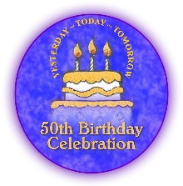
We are having a party and you are invited! Come celebrate at our 50th Birthday Bash! TTIA 6th International Congress May 5-7, 2022
Yesterday, Today, Tomorrow
Tarrytown, New York

Therapeutic Touch Memories

The Birthday Bash will be an amazing opportunity to share our stories about Therapeutic Touch – 50 Years of TT! Some people tell a great story and others write well. We are reaching out to every member of TTIA to ask you to share the following templates with people who are no longer members. We want to hear their stories too.
Please submit as soon as you can, but before March 31st.

BIG QUESTION – What has Therapeutic Touch Meant to Your Life?
E-Book
Title -
Author -
Story - Limit to 350 words

Audio File – MP3 or MP4
Title -
Author -
Audio file – 1 minute or less – Please record what you have written -

Please Send this template and your audio MP3 or MP4 to ttia@therapeutictouch.org. Please put the words
E-BOOK STORY in the Subject Space.

Consent: I consent to have my story shared electronically, on the Therapeutic Touch International Association website and TTIA Social Media Pages, published in an e-book or an old-fashioned paper book. I have provided the name I am willing to share and have not used names of other people without their consent. This is an important voluntary donation to TTIA, there is no reimbursement for your submissions.

Signed ______________________________________________ DATE: _________________________
Print your name here: ____________________________________________________

