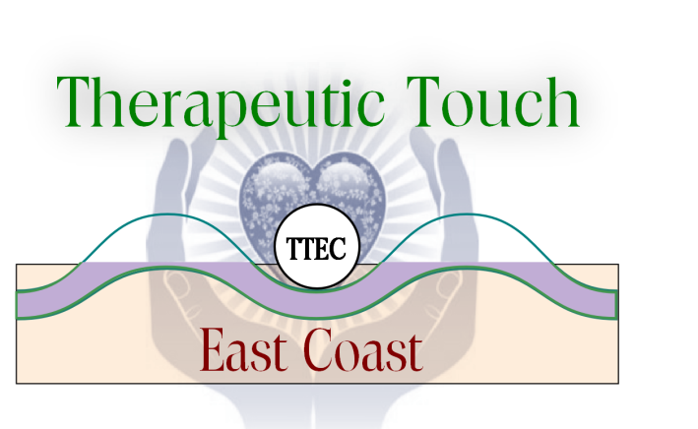
A Satellite Chapter of Therapeutic Touch International Association Presents
Shift Happens
How Therapeutic Touch Impacts the Practitioner
A Retreat for Healers
November 12th, 2022
9:30am-12:30pm
On ZOOM
How TT Influences Whole Health
Karen Kinman, PhD, RN, LMFT, TT practitioner since 1980. Karen integrates clinical hypnosis with TT in a private practice. Her specialties are pain management, cancer, and autoimmune disorders.
An interactive Dialogue with Guidance from our Panel
More information will be in the Zoom link to be sent the week of the program
Marilyn Johnston-Svoboda, RN, EdD, QTTP/QTTT a retired professor of nursing. Her holistic and compassionate philosophy has been deeply inspired by both Therapeutic Touch® (TT) and her Native American heritage, and is reflected in her teaching, practice and way of life
Luisa Porrata MPH, RN, CCAT, QTTT is a Bilingual—English/Spanish--Holistic Nurse Consultant in private practice. She studied with both Dora Kunz and Dr. Dolores Krieger at Pumpkin Hollow Farm beginning in the early 1980’s.

Retreat FEE: Free for TTEC Members Non-members Join TTEC for $30 and attend this program for free *Send to lgurick@gmail.com *

====================================================================================================
Name: ____________________________________________________________________
Address: __________________________________________________________________
City: _________________________________ ST: __________ Zip: ___________________
Phone #: _____________________________ Cell: _______________________________
E-mail: ___________________________________________________________________
Fee enclosed: $__________ Donation enclosed: $____________
Please make checks payable to TTEC Total enclosed: $__________
Mail registration and checks to Linda Gurick: 2185 Lemoine Ave Apt 8-o Fort Lee NJ 07024

