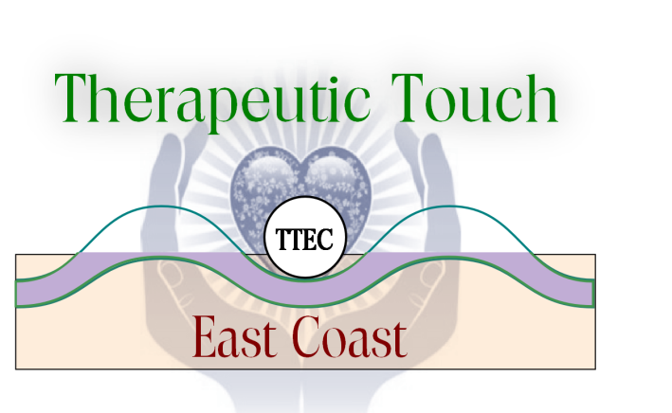
A Satellite Chapter of Therapeutic Touch International Association Presents
Wholeness and Therapeutic Touch®
A Retreat for Healers
6 PM Friday June 23rd – 2 PM Sunday June 25th, 2023
Come Explore the Dance of Wholeness
with Sue Conlin BA, QTTT
Early Bird deadline extended to April 28th, 2023
Let’s explore together the dance that occurs when we move from chaos to order and the wholeness that results from that movement. How does the practice of Therapeutic Touch impact that dance? Our exploration will not be just the physical concept of wholeness but the wholeness that we experience in our consciousness. Therapeutic Touch is about Shifts in Consciousness, and this is one more to recognize.
Is Wholeness only about the individual, or is it also the community? We will dialogue about the concept of wholeness, meditate, use movement, writing, sound, and nature to dive deeper, and of course we will share Therapeutic Touch.
Wiawaka Retreat for Women is located in beautiful Lake George, NY. Wiawaka is the oldest continuously operating women’s retreat center in the country. Check in is any time after 4 PM on Friday, June 23rd, and we will have a pot luck supper at 6 PM followed by an introduction to our topic, and what will undoubtedly be some thought provoking dialogue. Saturday’s events include all three meals and more deep diving (there’s even the waters of Lake George). After dinner we will meet and meditate together around a bonfire, and Sunday we have breakfast, a labyrinth walk, wrap-up and closing ceremony before lunch. Check out time is 2 PM. Wiawaka is a WOMEN ONLY retreat center.
Wiawaka offers gluten free (but not gluten safe if someone is celiac) and vegetarian options. For any other dietary restrictions we encourage people to bring their own food. There are refrigerators in every house.

Sue Conlin, BA QTTT, has been practicing Therapeutic Touch® since 1990, teaching TT since 1998, and studied extensively with the late co-creator of Therapeutic Touch, Dolores Krieger PhD, RN, Professor Emerita of NYU College of Nursing. Sue is the Operations Manager of Therapeutic Touch International Association (TTIA) and is credentialed by Nurse Healers Professional Associates International, Inc., the educational arm of Therapeutic Touch International Association (TTIA). Sue is one of the Founders of Therapeutic Touch East Coast, Inc. and served as its Treasurer for a number of years. She currently serves as the e-newsletter editor. She teaches about TT wherever and whenever people will listen.
A Satellite Chapter of Therapeutic Touch International Association Presents
Wholeness and Therapeutic Touch®
A Retreat for Healers
6 PM Friday June 23rd – 2 PM Sunday June 25th, 2023
Retreat FEE (Includes Room and Board):
$375. Early Bird Received by 4/28/23 ($367. USD International Discount)
$400. Received after 4/21 before June 1st, 2023 ($388. USD International Discount)
*Email registration form to mforestlove@gmail.com & tttrainer@verizon.net
Even if you are paying by check send that email to hold your spot. Registration will be complete when payment is received. Space is limited to 20 people.
* See payment instructions below*
No-one will be turned away because of finances - scholarships are available

====================================================================================================
Name: ____________________________________________________________________
Address: __________________________________________________________________
City: _________________________________ ST: __________ Zip: ___________________
Phone #: _____________________________ Cell: _______________________________
E-mail: ___________________________________________________________________
Fee enclosed: $__________ Donation enclosed: $____________
Please make checks payable to TTEC, Inc. Total enclosed: $__________
Mail check to
TTEC c/o Mary Caron
PO Box 851
Middlebury, VT 05753 USA
Paying by credit card? Check here _______ and email this form to mforestlove@gmail.com. You will receive an invoice with a link to pay by credit card.

Wiawaka Retreat June 2023

