 | Foundations  of  Therapeutic Touch®  Krieger-Kunz Method  Compassion Wholeness Conscious Presence
Are you a healthcare or hospice worker, or a caregiver for family or friends who wants to help facilitate relief from anxiety or physical discomfort? Do you want balance in your life and the lives of others?  After completion of this course the student will be able to:  a. Name 3 characteristics of a centered state  b. Provide an introduction of a TT session to a recipient/healing partner, including some history and theory of TT  c. Describe and demonstrate all the steps of a TT session  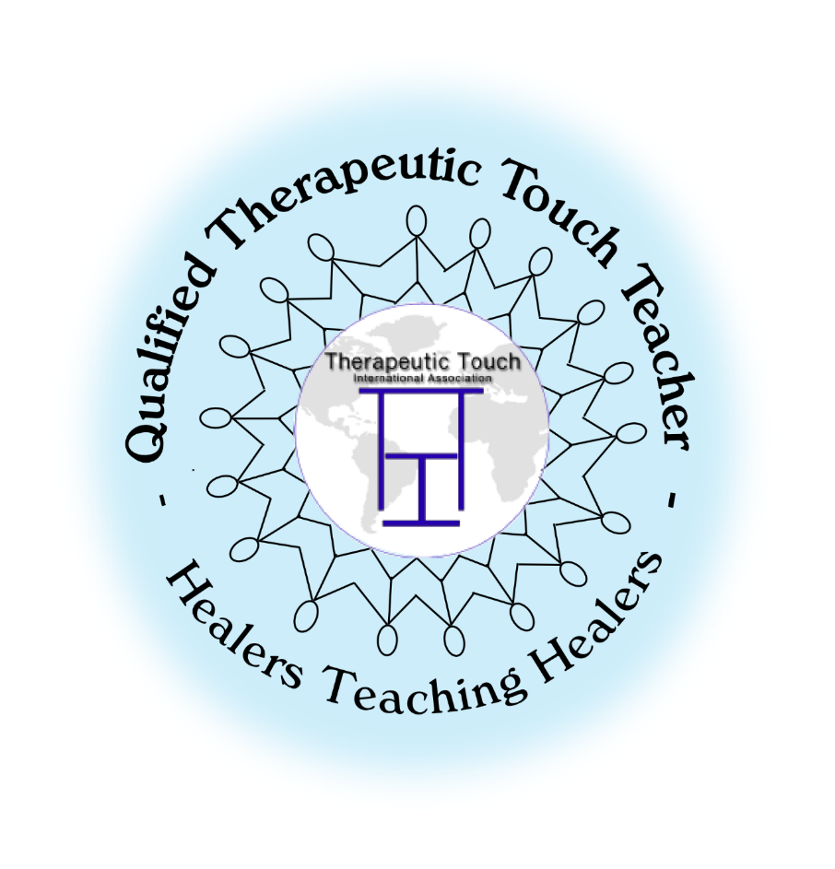  _____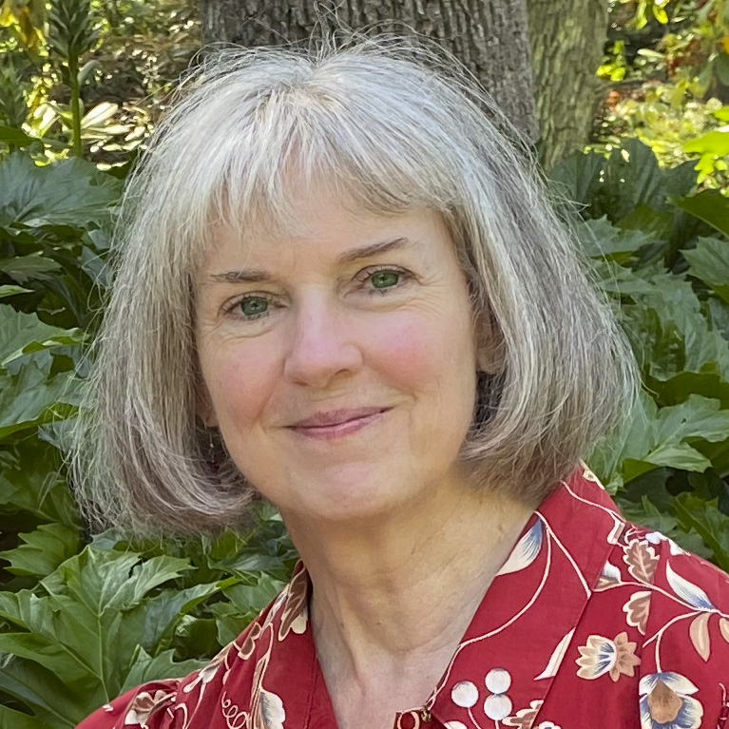____________ | This course teaches Therapeutic Touch® that is used in healthcare professions (nurses, massage therapists, physical therapists, counselors) and in hospice. This gentle and non-invasive method is also used by laypeople with family, friends, and others. Practitioners use these energy healing techniques - designed to support the body's own natural potential for healing - to assist the recipient in achieving relaxation, balance, and a sense of well-being ("healing" and "healing technique" in this context do not meaning curing or treating the physical body).  CEs available: This nursing continuing professional development activity was approved by the American Holistic Nurses Association (AHNA), an accredited approver by the American Nurses Credentialing Center's Commission on Accreditation. AHNA Approval #1805.  Where: Eugene, Oregon (address to be provided when registered)  When: June 9 (10A-3P), 11 & 18 (10A-2:30P), 2025  Cost: Sliding scale $75-$150 (includes TT book & course materials)  Certificate provided upon completion.  Course meets the curriculum requirements of  Therapeutic Touch International Association (TTIA) for Foundations level.  Lin Reilly, BA, QTTT is a Qualified Therapeutic Touch Teacher, credentialed 2010, and has been practicing Therapeutic Touch® (TT) since 1999. Lin studied TT with Neila Campbell, TT co-founder Dolores Krieger, and other faculty, and continues to attend TT programs and workshops. Lin has served several times as a mentor at the TT Mentorship Program at Camp Indralaya, Orcas Island, WA. In 2016 she retired from her profession as a Sr. Grant and Contract Officer in the Research Office at Oregon State University. The many aspects of TT are an integral part of Lin’s life path. She is a member of Therapeutic Touch International Association (TTIA) and formerly served on its Board of Trustees.  Contact information for pre-registration (required) or questions:  LinReilly.heart@gmail.com  Cell/text: 541-650-8345  Landline (no text): 541 431-6691

