Transpersonal Nature of
Therapeutic Touch^{® January 2026}
In this Therapeutic Touch® (TT) course, we build on the knowledge, skills, and insights acquired through the TT Foundations course and regular TT practice. This course supports and enhances the learner’s evolving and deepening understanding of Therapeutic Touch. We will explore in-depth approaches for assisting individuals with a variety of health challenges. It includes more hands on practice, reflective inquiry, and self inquiry exercises. And as always, peace and healing is the nature of the class for all who come! This course satisfies the second class required for the credential of Qualified Therapeutic Touch Practitioner (QTTP) however it is open to those who wish to deepen their practice but are not pursuing a QTTP. All sessions are required.

DATES: January 10-11, 2026
TIME: 9a to 5p each day with pre-class reading (14 total hours)
LOCATION: In person, Theosophical Society in Wheaton, Illinois
Class Fee $190.00 register at www.theosophicalsociety.org

Prerequisite required: Foundations of Therapeutic Touch
Continuing Nursing Education (CNE) Units The Transpersonal Nature of Therapeutic Touch® This continuing nursing education activity was approved by the American Holistic Nurses Association (AHNA), an accredited approver of continuing nursing education by the American Nurses Credentialing Center’s Commission on Accreditation.#1472 (14 CNE’s)
Teachers
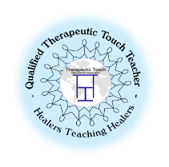
Marilyn Johnston-Svoboda EdD RN QTTP, QTTT(Qualified TT Teacher);
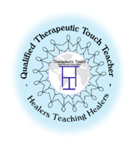
TT practitioner for over 45 years, a student of Dora Kunz and Dr Delores Krieger
(creators of TT), a retired nursing professor, teaches TT courses, mentors students, and maintains a private TT practice. She is a member of Therapeutic Touch International Association (TTIA), the TTIA Credentialing Chair, serves on the Education committee, and chairs the TTIA Community Care committee; a member of Sigma Theta Tau. She integrates her holistic values and beliefs, reflecting her Native American heritage into her TT practice. She creates a caring, peaceful, and healing setting for those who come to learn or receive TT.

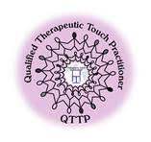
Madonna Pence BA, QTTP (Qualified Therapeutic Touch Practitioner) is a retired technical writer and editor. Madonna has practiced energy healing for more than 25 years, and TT for over 10 years. She provides TT for individuals with cancer at the Wellness House/Hinsdale, Il, along with maintaining a private TT practice. To complete her QTTT mentorship, she co teaches with Dr M. Johnston-Svoboda. Madonna is a member of Therapeutic Touch International Association (TTIA) and is the current President for that organization.

