Therapeutic Touch® at Pumpkin hollow
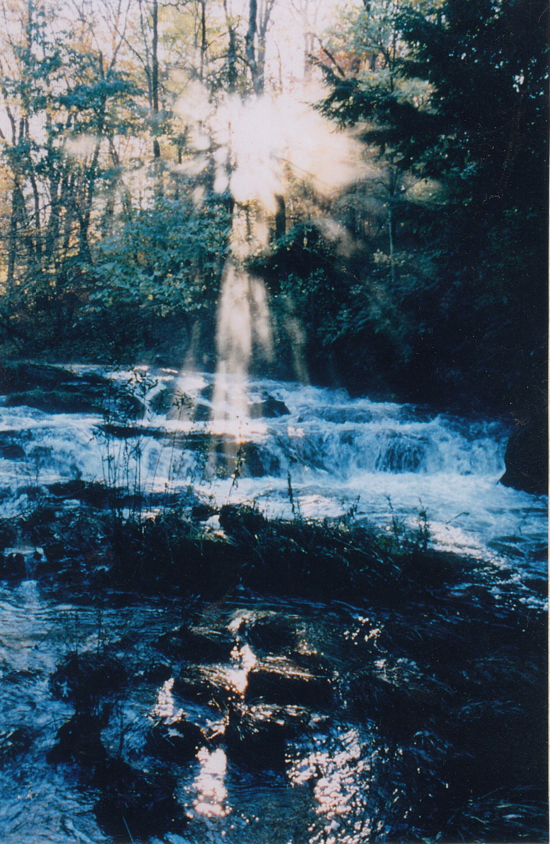
Pumpkin Hollow Retreat Center
~Where it All Began~
The birthplace of Kreiger Kunz model of Therapeutic Touch is offering a 3-day program covering many facets of Therapeutic Touch. There will be abundant opportunities to learn, share and practice TT amongst old friends and new in the magical natural setting of the Hollow. Early registration is encouraged. Whether you are a returning friend or planning your first visit, the weekend promises to be special.

August 6-9,2026
Information online at http://pumpkinhollow.org
518-325-3583 pumpkin@taconic.net



